Ideation Phase
Define the Problem Statements

Date | 18 June 2026
Team ID
Project Name | SHOPEZ : E-commerce Application
Maximum Marks | 2 Marks

Customer Problem Statement Template:
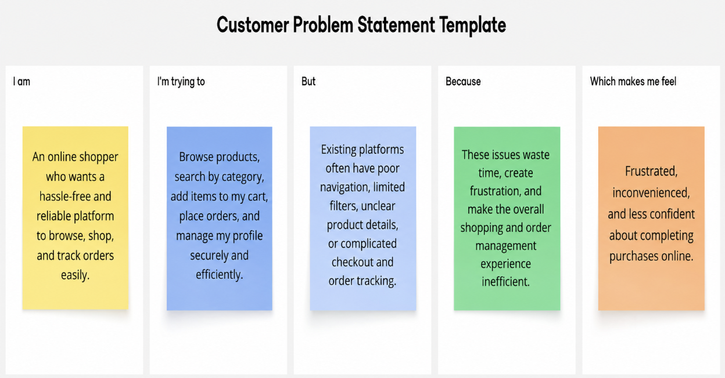

Problem Statement (PS) | I am (Customer) | I’m trying to | But | Because | Which makes me feel
PS-1 | An online shopper | Browse and purchase products easily from an online store | Finding suitable products and completing purchases can be difficult | Many shopping websites have poor navigation, limited search options, and cluttered interfaces | Frustrated and dissatisfied
PS-2 | An online customer who shops regularly in one place | Add products to my cart, manage quantities, and place orders smoothly | Managing cart items and reviewing purchases is often confusing | Some platforms lack simple cart management and clear order summaries | Annoyed, uncertain, and hesitant to complete my purchase

